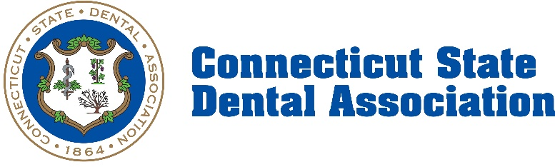

April 2nd, 2025

Contact: [kgerrity@csda.com](mailto:kgerrity@csda.com)

Appropriations Committee   
Connecticut General Assembly  
Legislative Office Building  
300 Capitol Avenue  
Hartford, CT 06106

**Senator Osten, Representative Walker, and members of the Appropriations Committee:**

My name is Kathlene Gerrity, and I serve as the Executive Director of the Connecticut State Dental Association. I appreciate the opportunity to submit testimony in support of Raised Bill No. 7254, An Act Concerning the Department of Social Services’ Implementation of Changes Resulting from the Medicaid Rate Study.

As this bill moves forward, I respectfully urge the Committee to give special attention to how dental Medicaid rates are set. Dental care presents a unique challenge within Medicaid, largely because the majority of dental procedures are not covered by Medicare. This makes Medicare an ineffective and inappropriate benchmark for rate-setting in this area. Similarly, comparing Connecticut’s rates to those of other states—such as New York, Massachusetts, Maine, Oregon, or New Jersey—offers limited value, since those states rely on methodologies shaped by different budget constraints, political landscapes, and regional priorities. These comparisons do not reflect the real cost of care here in Connecticut.

Instead, we encourage the state to adopt FairHealth as the foundation for setting dental Medicaid reimbursement rates. FairHealth is a nationally recognized, independent database that draws from real claims data, including dental procedures, and can be filtered by ZIP code. This means it provides an accurate reflection of the actual costs associated with delivering care in specific communities across Connecticut, whether urban or rural. Basing rates on this kind of data would create a more fair, predictable, and regionally responsive system.

There is an urgency to this issue that cannot be overstated. Dental disease is on the rise in Connecticut, especially among children between the ages of 6 and 11. At the same time, more providers are choosing to leave the Medicaid program because current reimbursement rates simply do not cover the cost of care. This is already leading to reduced access across the state. At Bridgeport Hospital’s Ambulatory Center, affiliated with Yale, dental surgeries for children performed in the operating room are being canceled because the procedures are no longer financially viable. Last year, the center treated 771 children. This year, they expect to cancel approximately 75 percent of those cases, leaving around 575 children without access to the care they need. The Community Health & Wellness Center has shut down its dental program entirely as of February 28, 2025, after losing $350,000 on major dental procedures in the previous year. StayWell Health Center has also had to scale back, no longer offering complex dental treatments such as root canals or crowns.

These are not isolated incidents. Over 400,000 patients are affected by such reductions in dental services across Connecticut, and more than 60 percent of those patients are enrolled in Medicaid. Without action, these trends will worsen and the consequences will extend far beyond oral health. According to the American Dental Association’s Health Policy Institute, eliminating adult dental benefits in Connecticut alone would lead to more than $43 million in additional annual healthcare costs due to preventable emergency room visits and complications from chronic conditions like diabetes, coronary artery disease, and pregnancy. Nationally, that figure exceeds $1.9 billion each year.

The human cost is just as sobering. Nearly one in three low-income adults say the condition of their teeth prevents them from securing employment. In Connecticut, this means that an estimated 46,959 residents could face economic barriers if dental Medicaid benefits are reduced or eliminated.

But there is a path forward. By embracing FairHealth as the basis for rate-setting, Connecticut would ground its Medicaid dental reimbursement system in real-world data rather than outdated benchmarks or politically driven comparisons. Doing so would strengthen the state’s provider network, offer greater transparency, and ultimately reduce long-term health costs through better access to preventive and comprehensive care.

As you consider this legislation, I also ask you to reflect on the words of Senate President Pro Tempore Martin Looney of New Haven, who spoke recently on the danger of federal healthcare cuts. He said, “People will die as a result of this proposed federal cut. Children will die. Parents of young families will die. Those who are in frail health will die. Elderly people will die. That’s what this is all about if the attorney general and his colleagues are not successful in reversing this decision. This is one of the most appalling things I have ever heard — the government turning against its own people and the neediest and most vulnerable of its own people.”

These cuts, if left unaddressed at the state level, will have life-altering consequences for thousands of Connecticut residents. I urge the Committee to ensure that any implementation of the Medicaid Rate Study, including under Raised Bill No. 7254, prioritizes a rate-setting process for dental Medicaid that is data-driven, equitable, and responsive to the actual cost of care in our communities.

Thank you for your time, your attention to this matter, and your continued commitment to protecting access to dental care for the people of Connecticut.

 Sincerely,

Kathlene Gerrity, Executive Director of the Connecticut State Dental Association.

###

The Connecticut State Dental Association (CSDA), a statewide professional membership association and statewide constituent of the American Dental Association, is dedicated to the professional development of its member dentists through initiatives in education, advocacy, the promotion of the highest professional standards, and championing oral health to improve the health of Connecticut residents. For more on the CSDA, visit [csda.com](http://www.csda.com/).