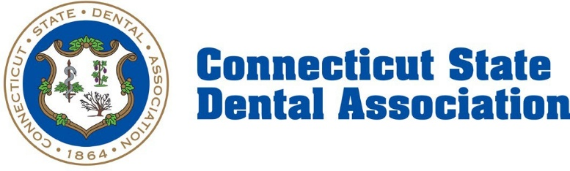
News Release
July 14, 2025
Contact: Jake Smith, Director of Communications
jsmith@csda.com

Connecticut State Dental Association Praises Legislature for Action, Governor for Signing State Law on Community Water Fluoridation
As a result of strong advocacy grounded in science and collaboration, Connecticut has become the only state in the country this year to affirm fluoridation by passing legislation requiring large public water systems to maintain optimal fluoride levels. Landmark legislation approved during the 2025 legislative session has now been signed into law by Governor Ned Lamont, earning praise from the Connecticut State Dental Association.
“In stark contrast to the fluoride ban in Utah, Florida, and, most recently in Oklahoma, I am proud to be practicing in Connecticut where there has been a proactive approach to protecting community water fluoridation,” said Dr. Brianna Muñoz, a board-certified pediatric dentist, American Dental Association Fluoride Ambassador and President of the Connecticut Oral Health Initiative.
Backed by more than 75 years of scientific research and proven public health outcomes, community water fluoridation remains one of the most effective and economical strategies for preventing tooth decay. Fluoridated water reduces cavities in children and adults by up to 25%, even with regular use of fluoride toothpaste.
In addition to health benefits, water fluoridation offers major cost savings. On average, every $1 invested saves $38 in dental treatment—making it a critical tool for both preventive care and long-term economic impact.
“Recognized by the CDC as one of the 10 greatest public health achievements of the 20th century, water fluoridation has been proven to prevent tooth decay for the entire community in the most equitable and cost-effective manner,” said Dr. Muñoz. “Community water fluoridation is the only way to cross socioeconomic lines and to benefit those living in the shadows of society who may not otherwise have access to dental care.”
The Connecticut State Dental Association (CSDA) joins over 100 leading health organizations—including the American Dental Association (ADA), Centers for Disease Control and Prevention (CDC), World Health Organization (WHO), American Medical Association (AMA), and American Academy of Pediatrics (AAP)—in reaffirming the safety, effectiveness, and public health importance of community water fluoridation.
“Connecticut’s legislators and Governor Lamont have acted expeditiously and effectively to protect the health of Connecticut residents by ensuring that community water fluoridation remains in place here. CSDA appreciates their diligence on this issue, and commitment to prioritize public health over disinformation,” said Kathlene Gerrity, Executive Director of CSDA.
The Connecticut legislation codifies the amount of fluoride that water companies must add to the water supply, rather than tying the amount to federal Department of Health and Human Services (HHS) recommendations as current law does, according to the Connecticut Office of Legislative Research. In doing so, it maintains the current required level. Specifically, it requires water companies to add enough fluoride to maintain an average monthly fluoride content of 0.7 milligrams per liter (mg/L), within a range of 0.15 mg/L greater or lower than this amount. As under current law, the bill applies to water systems that serve at least 20,000 people.
The CSDA denounces recent misinformation around fluoridation. Statements by Florida Surgeon General Joseph Ladapo labeling fluoridation as “medical malpractice” have been widely rejected by public health experts. ADA President Dr. Brett Kessler has called these remarks “misinformed and dangerous.”
A recent JAMA Pediatrics article that raised concerns about fluoride and IQ presented no new evidence and relied on a National Toxicology Program report that failed peer review twice and was significantly revised prior to release. Current research continues to confirm the safety of fluoride at recommended levels.
The CSDA remains committed to defending evidence-based public health policy and supporting efforts that improve equitable access to oral health for all.

###
The Connecticut State Dental Association (CSDA), a statewide professional membership association and statewide constituent of the American Dental Association, is dedicated to the professional development of its member dentists through initiatives in education, advocacy, the promotion of the highest professional standards, and championing oral health to improve the health of Connecticut residents. For more on the CSDA, visit csda.com.

